A Study of FPGA-based System-on-Chip Designs for Real-Time Industrial Application

## Team 1

**Team members:** Nichenametla Yadhu Vamsi, Rashmi Singh, Chandan Kumar, Vishesh Chhaperwal, Kush Thakur, Ranga Sudharani, Khushi Prajapati

**The IC architecture referred in this paper**: FPGA based SOC

This paper explains why Field Programmable Gate Arrays (FPGAs) are great for industrial control. It starts by listing FPGA benefits and where they are useful. The author also evaluated FPGA performance and design tools. They demonstrated FPGA benefits with a real example: detecting and tracking faces in real-time using an Altera DE2-SoC board. Algorithms to filter images were coded in Verilog for the board.

## Architecture/ Block Diagram:

FPGA vendors cater to System-on-Chip (SoC) trends by offering comprehensive software development tools such as editors, compilers, assemblers, linkers, and debuggers. The design flow for developing SoC applications typically includes hardware and software design procedures. A user-friendly interface enables designers to specify the processor needed for a project. Once configured, the processor core is generated as an HDL file or a netlist file. This core can then be combined with custom user logic and integrated into the hardware design flow for synthesis, placement, and routing.

FPGAs are configured with a resulting bitstream file, allowing integration of soft processor cores that interpret associated library files. These processors support C/C++ compilers provided within the development system, enhancing flexibility and ease of programming for embedded applications.

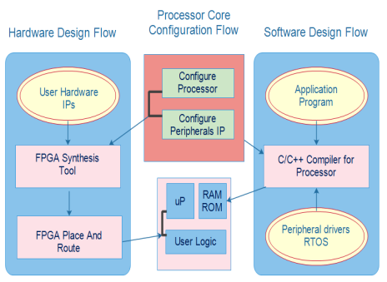

Fig. 1. Typical FPGA SoC design flow

FPGA vendors provide comprehensive design tools supporting high-quality processes from hardware description in Verilog or VHDL to final bitstream generation. These tools offer flexible design features and include simulations (e.g., ModelSim) and debugging tools (e.g., ChipScope from Xilinx). The workflow involves describing hardware, synthesizing, placing and routing, and generating a bitstream for FPGA configuration. They simplify development, ensuring efficient and reliable FPGA-based system design and testing.

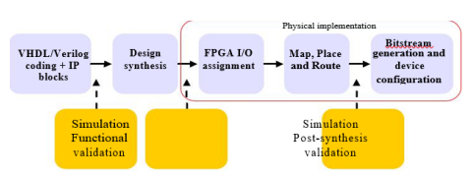

Fig. 2: Simplified synoptic of the FPGA design process

Color segmentation has proven to efficiently detect face regions, regardless of implementation specifics, while requiring minimal computational resources. Unlike feature-based methods, the color-based algorithm requires very little training.

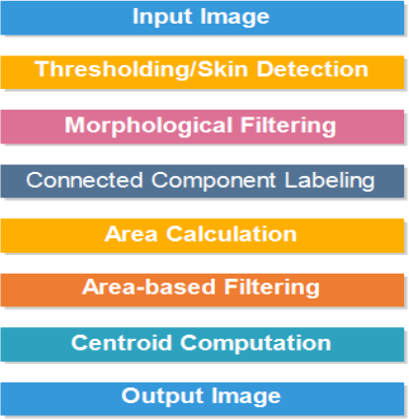

Fig. 3: Software algorithm

First, the original image is converted to a different color space, specifically modified YUV. Then, a process identifies skin pixels based on a specific range of colors using an algorithm. To refine the results and reduce errors, morphological filters are applied. Next, each identified pixel is labeled, and the area of each labeled region is calculated. A filter based on region size is applied to retain only larger regions, which are considered potential face areas. Finally, the centroid (center point) of each identified face region is computed to indicate its location on the image.

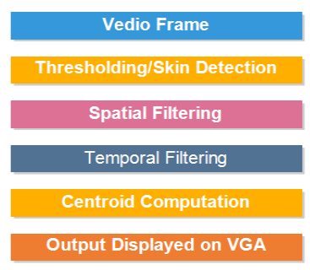

Fig.4. Hardware algorithm

## Functional Description of the Solution

* The solution provided in the research paper involves the implementation of a real-time face detection and tracking application using a Field Programming Gate Array (FPGA) on a DE2-SoC Altera board.
* The application relies on calculating the centroid of each detected region for face tracking, which is achieved through the use of specific algorithms translated into Verilog code to run on the DE2-SoC board.

## Features of the IC

The DE2-SoC Altera board used in the solution is equipped with various features that make it suitable for real-time industrial applications:

* The board integrates a Cyclone V FPGA, which provides programmable logic elements and embedded memory blocks for implementing complex algorithms efficiently.
* It features a dual-core ARM Cortex-A9 processor, offering high-performance processing capabilities for handling real-time tasks and computations.
* The board includes various peripherals such as GPIOs, VGA display output, and audio codec interfaces, enhancing its connectivity and usability in diverse industrial applications.
* The FPGA-based solution leverages the reconfigurability and parallel processing capabilities of FPGAs to achieve real-time performance in face detection and tracking applications.
* The FPGA design tools used in the solution enable the translation of algorithms into hardware description language (HDL) code, facilitating the implementation of complex functionalities on the FPGA platform.

The DE2-SoC board's integration of FPGA and ARM processor allows for a hybrid processing approach, where intensive computational tasks can be offloaded to the FPGA for accelerated processing while the ARM processor handles general-purpose computing tasks efficiently.

The solution's use of FPGA technology offers flexibility in modifying and optimizing the face detection and tracking algorithms, making it adaptable to different industrial scenarios and performance

requirements.

## Conclusion:

This research paper has explored the FPGA’s technologies and their applications in industrial control systems. It highlighted the benefits of using FPGAs, such as high performance, reliability, speed, and flexibility. The study compared synthesizable and non-synthesizable processor cores, emphasizing their advantages and uses. Additionally, a real-time face detection and tracking system was implemented using FPGA technology, demonstrating its effectiveness and efficiency. The results confirmed that FPGAs are a valuable asset in developing high-performance industrial applications.

Overall, the solution showcases the effectiveness of FPGA-based System-on-Chip (SoC) designs in real-time industrial applications, highlighting the benefits of hardware acceleration and parallel processing for demanding tasks like face detection and tracking.